DAT102x Predictive experiment

# Loan Granting Binary Classification December 2016

## Azure ML experiment overview:

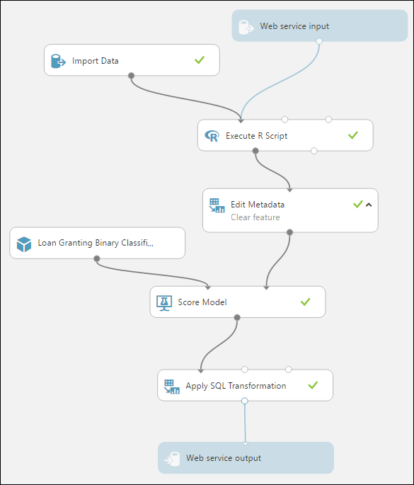

## Detailed view of all steps:

1. Web Server Input  
   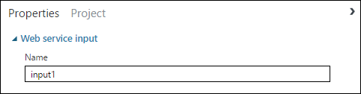
2. Import Data  
   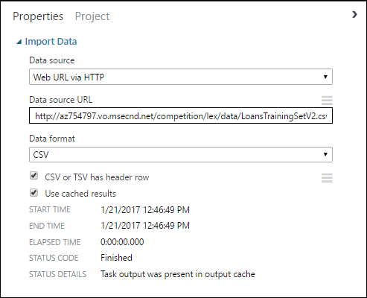
3. Execute R Script (see Dat102x-WebService.r)  
   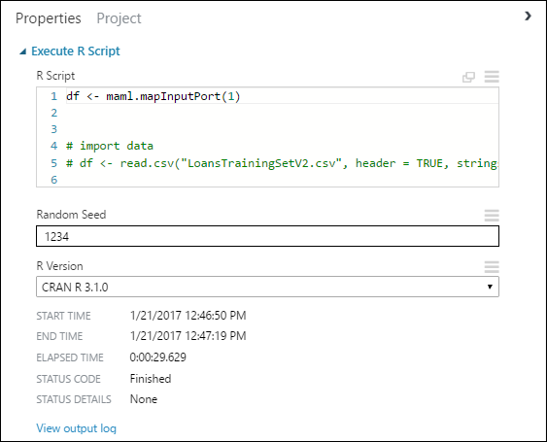
4. Edit Metadata  
   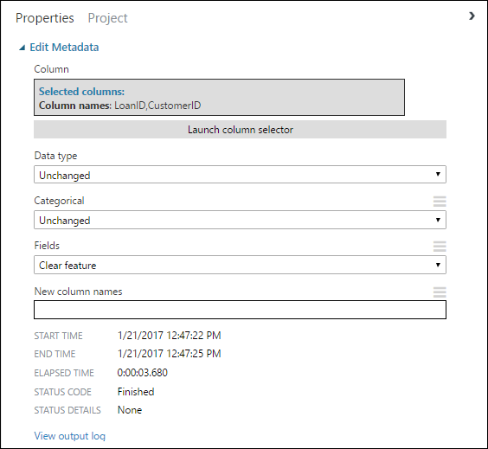
5. Score Model  
   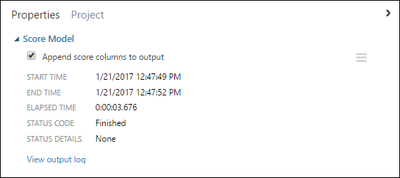
6. Loan Granting Binary Classification December 2016 - New NY04 [trained model]  
   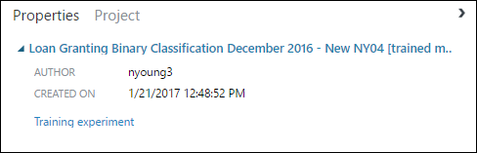
7. Apply SQL transformation  
   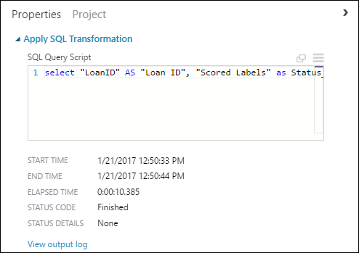
8. Web Service Output  
   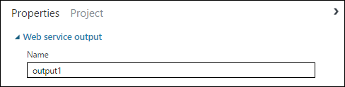

## Competition page and results:

<https://gallery.cortanaintelligence.com/Competition/1ad7a6df99794816b9bc071e27d46b10#leaderboardButton>

* 744 participants
* 13,734 submissions

